Data Visualisation 2 Report

Albert Chow, 29694523  
Wednesday 11am Studio 02  
Tutor: Joe Liu

Link: <https://abhchow.github.io/FIT3179_Visualisation2/index.html>

Word count:

# Domain

The domain of my visualisation is energy. It explores the use of different energy sources across the world, and focuses on Australia for a case study.

# Why? And Who?

To communicate to the average Australian how much energy is being used both across the world and at home in Australia. Furthermore, to also explore how different energy sources make up the energy mix in Australia and worldwide, across time.

# What?

I have used 2 publicly available datasets.

* <https://ourworldindata.org/energy-mix#it-s-the-total-amount-of-fossil-fuels-we-burn-that-matters-and-we-continue-to-burn-more-each-year>
* <https://data.worldbank.org/indicator/SP.POP.TOTL>

The first is the raw energy data across time for all the different countries.

I have further processed using a combination of Excel and Python scripts to format it in a machine readable format. The scripts are available in my GitHub repository.

Why and How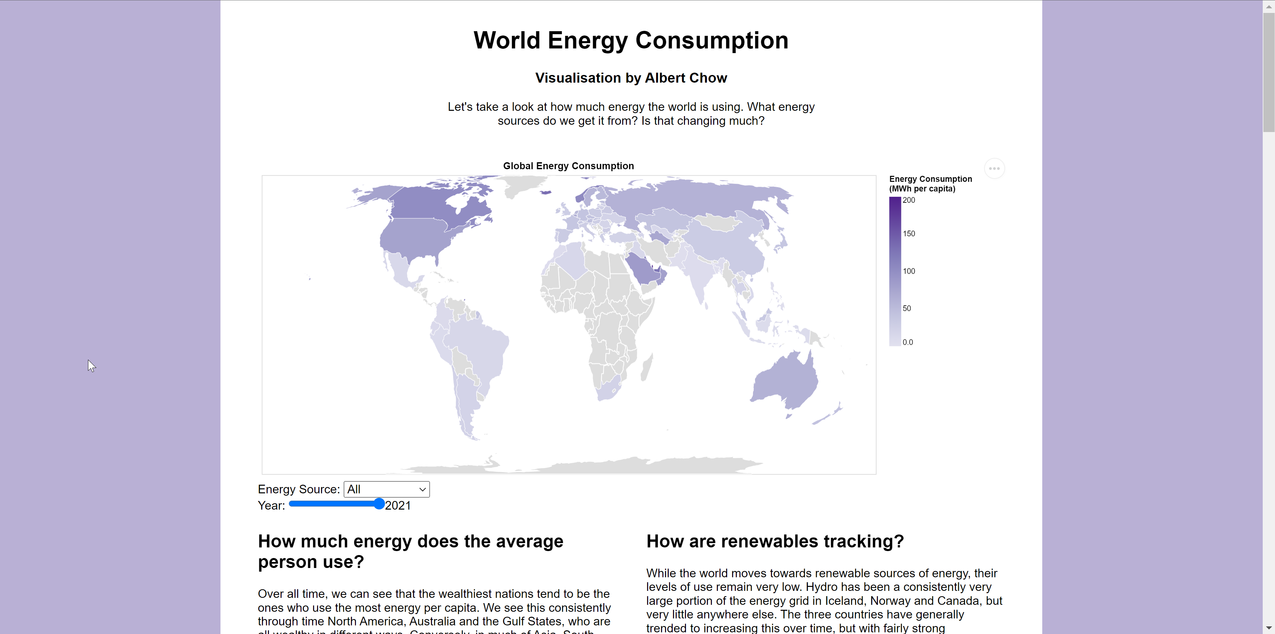

I have chosen 3 idioms for my visualisation which were deliberately quite simple – these were a chloropleth map, 2 stacked bar charts and 2 line charts. This is because they are simple to interpret, and don’t encode any superfluous information.

The chloropleth map gives an overview of the different energy consumptions per capita for each country. A chloropleth map was good for this as it helped to compare a large amount of countries and regions, and how each of them changes over time, and with respect to different energy sources.

The Total Energy Consumption chart allows viewers to easily see what the total energy use for a country is over time, and as a bonus gives an indication of what sources are being used. The line chart below it elaborates on this and allows for more detail in comparing the different sources, allowing the viewer to better understand how the different sources within the energy mix are interacting with each other.

The two graphs below them are both presented together for the exact same reason. I put both the normalised and un-normalised graphs there as it is important to communicate to the viewer that a per capita decrease in a source can still be underpinned by an increase in a source – so the power plants that are running those sources would not be closing any time soon!

# Design

### Layout

I structured my visualisation into 2 main sections: a global view, and the case study. The case study had 2 subsections. Each of these (sub)sections occupied its own vertical space, taking up the full width of the visualisation and a section of vertical space.

The sightlines were mainly in two vertical lines. This partitioning helps the viewer to see the different information separated. These sightlines are deliberately broken with the centred headings and graphs, forcing the user to focus on the visual information presented.

### Colour

I did not elaborately use much colour in my visualisation – I kept it simple to reduce chartjunk. I simply assigned a number of colours to the field visualisations and ensured that similar colours were separated from each other.

I chose a sequential purple colour scale for the chloropleth map, and changed the background edges to purple to match. The sequential scale was chosen to clearly show that there is a hierarchy to the quantitative data being presented.

### Figure-ground and Typography

I used the size of text to impose a hierarchy to ensure the most important text was read first. The title/subtitle deliberately break the sightlines imposed on the rest of the visualisation to ensure that the reader is immediately drawn to them.

The whitespace between sections serves to indicate to the reader that the upcoming information is separate to what we’ve previously seen, and the use of an image at the top of each section quickly indicates to the user what the section will be about before they even read the section title.

### Storytelling

In conjunction with the layout, the user is guided into reading top to bottom and left to right, since the visualisation is quite vertically long. The user reads from the top and progresses through the sections, and then their attention is caught by the figures which are put on the left. Then they will progress to the more cognitively demanding text, which is positioned next to the figure.

# Bibliography

### Datasets:

Australian Government Department of Education and Training. 2022. *Student Enrolments Pivot Table*. [online] Available at: <https://www.dese.gov.au/higher-education-statistics/resources/student-enrolments-pivot-table> [Accessed 1 September 2022].

Australian Government Department of Education and Training. 2022. *2020 Student summary time series*. [online] Available at: <https://www.dese.gov.au/higher-education-statistics/resources/2020-student-summary-time-series> [Accessed 1 September 2022].